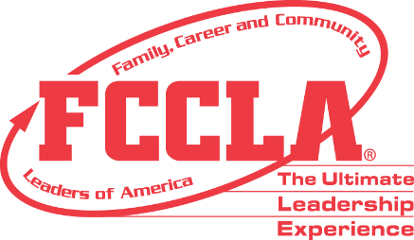
Scholarship Donation Form

Name of Person/Chapter/Organization Donating:
Name of Person/Chapter/Organization Donating

E-mail Address
Scholarship Donation Amount
Hurst Scholarship
Jeremy Jackson Scholarship
State Leadership Conference Scholarship
Total Donation

Please mail this form and the donation to: Indiana FCCLA
13208 Five Points Rd
Sunman, IN 47041

