TIME | ACTIVITY

Thursday, February 29, 2024
3:00 pm – 8:30 pm | FCCLA Conference Registration
3:00 pm – 4:00 pm | Orientation for New Advisers
4:00 pm – 9:00 pm | STAR Event Information
5:30 pm – 6:00 pm | State Project Check-In
4:00 pm | Orientation for LC & STAR Event Evaluators
4:45 pm – 8:30 pm | STAR EVENTS
Chapter in Review Display/Portfolio
Chapter Service Project Display/Portfolio
Entrepreneurship
Event Management
Fashion Design
Food Innovations
Interior Design
Job Interview
Leadership
National Programs in Action
Parliamentary Procedure
Public Policy Advocate
Sports Nutrition
Sustainability Challenge
Teach or Train

9:00 – 10:30 pm | Opening General Session

Friday, March 1, 2024
7:00 am – 6:00 pm | FCCLA Conference Registration  (STAR Event Information)
8:00 am – 3:00 pm | ProStart FCCLA Invitational  ProStart Management  Baking and Pastry Competition
8:00 am | Orientation for LC & STAR Event Evaluators
 | STAR EVENTS Morning Session
8:45 am- 12:00 pm | Career Investigation  Fashion Construction  Nutrition and Wellness  Professional Presentation  Repurpose and Redesign  Say Yes to FCS  Teaching Strategies
9:00 am – 3:00 pm | Prize Wheel
9:00 am – 3:00 pm | Exhibits
9:00 am – 10:00 am | State Project Check-In
10:00 am – 10:45 am | State Officer Candidate Speeches
10:45 am – 12:00 pm | State Officer Candidates Round Robin
9:00 am – 11:45 am | Youth Sessions
12:30 pm | Orientation for LC & STAR Event Evaluators
1:00 pm | Specific Orientation for STAR Event Participants
1:15 pm – 3:00 pm | STAR EVENTS Afternoon Session
Focus on Children
Early Childhood*
Hospitality, Tourism and Rec.*
Interpersonal Communications*
Parliamentary Procedure*
Promote and Publicize*

1:00 pm – 3:30 pm | Youth Sessions
4:00 pm – 5:30 pm | Second General Session
5:45 pm – 7:00 pm | Adviser Dinner
7:15 pm | State Project Line Up
7:30 pm – 9:00 pm | Third General Session/Business Meeting
9:30pm – 11:00 pm | Student Entertainment

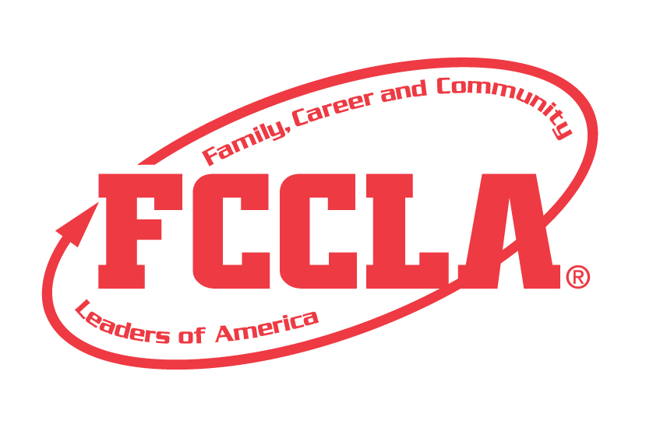

Saturday, March 2, 2024
9:00 am | Check out of Hotel
9:30 am | STAR Event Line-up
10:00 am – 12:00 PM | Closing General Session

