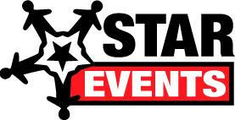
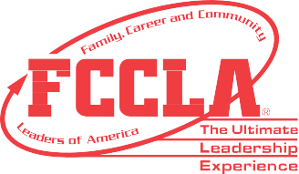

STAR Events (Students Taking Action with Recognition) is a program of Family, Career and Community Leaders of America (FCCLA) that builds student’s leadership and career-related skills at the local, regional, state, and national levels.
How do
STAR
Events
impact students
in your state?

Participants from
Indiana said:

In 2018-2019, 327 students completed 213 projects, reaching approximately 422,208 people

Why did we compete in STAR Events?

Participants from Indiana joined over 23,000 students competing in STAR Events. Students reported participating to increase leadership skills, to apply college and career-readiness skills to future goals, to meet personal, school, or community needs, and to learn and have fun!

How useful are STAR Events for my future?

Indiana students reported, along with 90% of all national participants, that these events are very or extremely useful as they prepare for future experiences.

Top skills we develop through FCCLA:

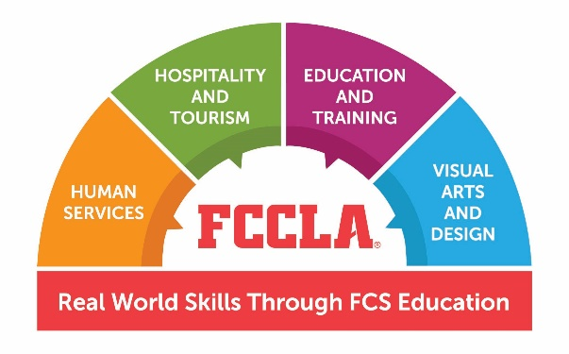
Awareness of Community or World | Public Speaking/Communication
Conflict Resolution and Respect | Responsibility/Time Management
Creativity | Self Confidence
Decision Making/Problem Solving | Specific Career Skills
Leadership | Teamwork
Professionalism and Integrity | Technology and STEM Skills
Working with Adults

These skills align with the Employability Skills Framework – skills required to be college and career ready - and support FCCLA’s mission to promote personal growth and leadership development through Family and Consumer Sciences education.

For more information, contact:
indianafccla@gmail.com
812.243.3539

