INDIANA
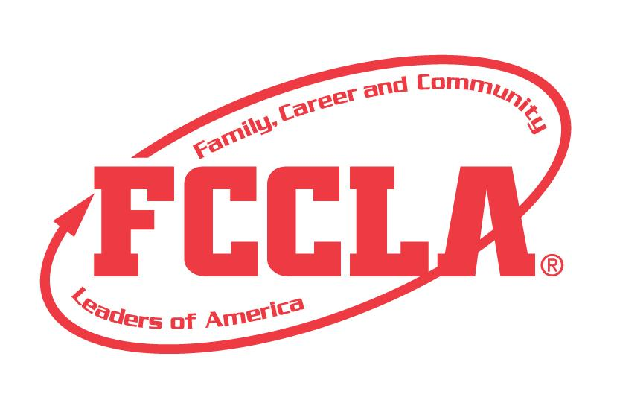
BEYOND THE
BASICS

STATE PROJECT
FCCLA members must be affiliated by February 1st

OVERVIEW: Beyond the Basics is a project designed to recognize students who know the basics of FCCLA and all it has to offer and can go beyond what they already know. Students must create a display demonstrating their increased knowledge and understanding of FCCLA.

Entry: Individual or Team (maximum of 3) Event

VISUAL GUIDELINES:
- Use of the planning process to develop your project and include the planning process summary.
- For this project a Trifold Board or Digital Presentation can be used.
  - Trifold Board: A tri-fold display board (not exceeding 18” deep X 4’ wide X 4’ high, with no use of electrical equipment).
  - Digital Presentation: PowerPoint or Google Slides presentation must be submitted with no more than 30 slides total. Name the file with the student first and last name, chapter name, and name of state project.

PROJECT DETAILS:
Display Board | Slides Presentation
- The title of the project, Beyond the Basics, must be included on the front of the board  - There must be a 3” X 5” index card attached to the lower corner on the back of the display that identifies: Name, Chapter name, School, City, State, Grade and District.  - Each step of the Planning Process is fully explained, neatly typed, no more than 1 page total for the Planning Process. | - The title of the project, Beyond the Basics, must be included (If digital: Title must be on Slide 1).  - A slide identifying: Name, Chapter name, School, City, State, Grade and District.  - Each step of the Planning Process is fully explained, neatly typed, and can be up to five slides total for the Planning Process.

4. The display or presentation must include the below items, each letter can be a slide or up to one page:

A. State Theme for the current school year
B. How many State officers do we have in the State of Indiana for the current school year?
C. What is the national membership campaign? Share one membership recruitment idea.
D. Choose 3 National Programs and explain a project idea for each program.
E. Explain the National Outreach Project.
F. Identify and explain all of the State Projects.
G. Where is the next National Leadership Conference?
H. Include an example of the National FCCLA Official Dress code.

5. The project will be evaluated according to the Beyond the Basics rubric.

FCCLA Planning Process
Summary Page Template
(This template may be modified, but all headings must be used in the correct order. The FCCLA logo and Planning Process graphics are encouraged but not required.)

IDENTIFY CONCERNS

SET A GOAL

FORM A PLAN (WHO, WHAT, WHEN, WHERE, HOW, COST, RESOURCES, AND EVALUATION)

ACT

FOLLOW UP

BEYOND THE BASICS
Self Score is Optional
EVALUATION |  |  |  | SELF  SCORE | SCORE
SLIDE PRESENTATION/DISPLAY  0 – 10 pts | Not neat or appealing. More than 2 required elements missing  0-3 | No Title  Missing 1or 2 required elements. Visual appeal could be improved  4-7 | Meets size specification, Title included  Neat and well organized and visually appealing  8-10
FCCLA PLANNING PROCESS  0 – 10 pts | Not attached  Not legible  0-3 | Available, but not attached  All steps are summarized  Somewhat messy  4-7 | Planning Process is fully explained, neatly typed and included.  8-10
GRAMMAR  0 – 15 pts | Extensive grammatical and spelling errors  0-4 | Few grammatical and spelling errors  5-9 | No grammatical or spelling errors  10-15
STATE THEME  0-5 pts | State theme missing  0-1 | State theme incorrect  2-3 | State theme correct  4-5
FCCLA STATE OFFICERS  0 – 5 pts | Missing  0-1 | Officers listed but no titles  2-3 | List the officers titles for the state of Indiana  4-5
FCCLA NATIONAL PROGRAMS  0 – 15 pts | Missing one or more of the National Programs  0-4 | Programs listed but no explanation  5-9 | Three national programs listed with explanation  10-15
NATIONAL OUTREACH PROJECT  0 – 5 pts | National Outreach Project not correct or missing  0-1 | National Outreach Project listed but no explanation  2-3 | National Outreach Project listed with explanation  4-5
FCCLA STATE PROJECTS  0 – 15 pts | Missing one or more of the State Projects  0-4 | State Projects listed and correct names  5-9 | State Projects listed with explanation  10-15
FCCLA NATIONAL LEADERSHIP CONFERENCE  0 – 5 pts | Not on board  0-1 | Date and/or location incorrect  2-3 | Date and location correct and on board  4-5
MEMBERSHIP CAMPAIGN AND IDEA  0-10 pts | Membership campaign named with no or little explanation.  0-3 | Membership campaign explained but missing ideas  4-8 | Membership campaign fully explained and idea present  9- 10
FCCLA DRESS CODE  0 -- 5 pts | Example of dress code missing  0-1 | Dress code included but not correct  2-3 | Dress code included and correct  4-5
TOTAL
100 pts possible (comments on back)

Name__________________________________________School___________________________________

0-69 | 70-79 | 80-89 | 90-100
Participation | Bronze | Silver | Gold

