INDIANA
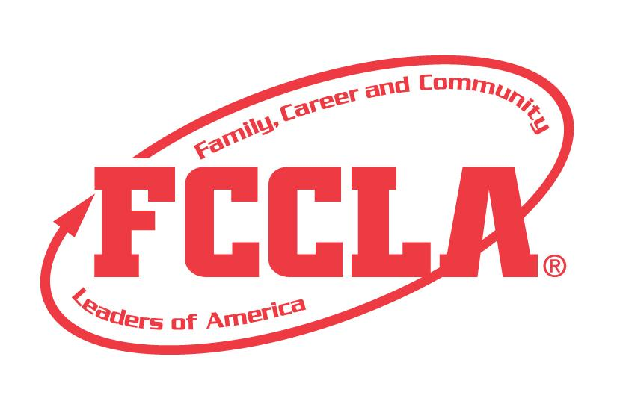
FOCUS ON THE BASICS

STATE PROJECT
FCCLA members must be affiliated by February 1st

Focus on the Basics

Overview: Focus on the Basics is a project to recognize students who use the planning process to understand the basics of Family, Career, and Community Leaders of America. Students must create a presentation demonstrating their increased knowledge of FCCLA that will be displayed at State Leadership Conference.

Entry: Individual or Team (maximum of 3) Event

VISUAL GUIDELINES:
- Use of the planning process to develop your project and include the planning process summary.
- For this project a Trifold Board or Digital Presentation can be used.
  - Trifold Board: A tri-fold display board (not exceeding 18” deep X 4’ wide X 4’ high, with no use of electrical equipment).
  - Digital Presentation: PowerPoint or Google Slides presentation must be submitted with no more than 30 slides total. Name the file with the student first and last name, chapter name, and state project.

PROJECT DETAILS:
Display Board | Slides Presentation
- The title of the project, Focus on the Basics, must be included on the front of the board  - There must be a 3” X 5” index card attached to the lower corner on the back of the display that identifies: Name, Chapter name, School, City, State, Grade and District.  - Each step of the Planning Process is fully explained, neatly typed, no more than 1 page total for the Planning Process. | - The title of the project, Focus on the Basics, must be included (If digital: Title must be on Slide 1).  - A slide identifying: Name, Chapter name, School, City, State, Grade and District.  - Each step of the Planning Process is fully explained, neatly typed, and can be up to five slides total for the Planning Process.

- The display or presentation must include the following, each letter can be a slide or up to one page:

  - What are 10 benefits of joining FCCLA?
  - List the eight FCCLA purposes and tell what each means to you.
  - Summarize the history of FCCLA.
  - What is the FCCLA Creed? What does it mean to you?
  - FCCLA colors and what they represent
  - FCCLA emblem and what it represents
  - FCCLA flower and what it represents
  - FCCLA motto and what it represents
  - FCCLA mission and what it represents

5. The project will be evaluated according to the Focus on Basics rubric.

FCCLA Planning Process
Summary Page Template
(This template may be modified, but all headings must be used in the correct order. The FCCLA logo and Planning Process graphics are encouraged but not required.)

IDENTIFY CONCERNS

SET A GOAL

FORM A PLAN (WHO, WHAT, WHEN, WHERE, HOW, COST, RESOURCES, AND EVALUATION)

ACT

FOLLOW UP

FOCUS ON THE BASICS
Self Score is Optional
EVALUATION |  |  |  | SELF  SCORE | SCORE
DISPLAY OR SLIDE PRESENTATION  0 – 10 pts | Does not meet the specifications. Not neat or appealing. More than 2 required elements missing  0-3 | No Title  Missing 1or 2 required elements. Visual appeal could be improved  4-7 | Meets size specification, Title included  Neat and well organized and visually appealing  8-10
FCCLA PLANNING PROCESS  0 – 10pts | Not attached  Not legible  0-3 | Available, but not attached  All steps are summarized  Somewhat messy  4-7 | Planning Process is fully explained, neatly typed or and included  8-10
GRAMMAR  0 – 10 pts | Extensive grammatical and spelling errors  0-3 | Few grammatical and spelling errors  4-7 | No grammatical or spelling errors  8-10
APPEARANCE  0 –10 pts | Presentation has minimal appeal both in design and content  0-3 | Presentation needs some improvement in design and content  4-7 | Visually appealing,  creative, and appropriate in design and content  8-10
PROJECT ID SLIDE  0 – 5 pts | Missing 2 or more ID elements or not provided  0-1 | Missing 1 ID element,  ID index card misplaced  2-3 | All ID elements on index card on board  4-5
FCCLA BENEFITS  0 - 10 pts | Few or No FCCLA Benefits  0-3 | Few Benefits listed  4-7 | 10 Benefits of joining  8-10
FCCLA PURPOSES  0 – 10 pts | Purposes and explanation are missing  0-2 | Most of the purposes listed with explanations  3-7 | Eight purposes listed with explanation  8-10
FCCLA HISTORY  0 – 5 pts | Missing several elements,  Summary lacks detail  0-1 | Summarized history of FCCLA in basic detail  2-3 | Summarized history of FCCLA in great detail  4-5
FCCLA  CREED  0 – 5 pts | Creed and explanation missing  0-1 | Creed or explanation incorrect  2-3 | Creed listed with an explanation  4-5
FCCLA EMBLEM  0 – 5 pts | Emblem and explanation missing or incorrect  0-1 | Emblem or explanation missing or incorrect  2-3 | Emblem present with an explanation  4-5
FCCLA  COLORS  0 – 5 pts | Colors and explanation missing  0-1 | Color or explanation incorrect  2-3 | Colors listed with an explanation  4-5
FCCLA  FLOWER  0 – 5 pts | Flower and explanation missing  0-1 | Flower or explanation incorrect  2-3 | Flower is present with an explanation  4-5
FCCLA MISSION  0-5pts | Mission and explanation missing  0-1 | Mission or explanation  incorrect  2-3 | Mission is listed with an explanation  4-5
FCCLA MOTTO  0-5 pts | Motto and explanation missing  0-1 | Motto or explanation  incorrect  2-3 | Motto is listed with an explanation  4-5
TOTAL
100 pts possible (comments on back)

Name__________________________________________School___________________________________

0-69 | 70-79 | 80-89 | 90-100
Participation | Bronze | Silver | Gold

