INDIANA

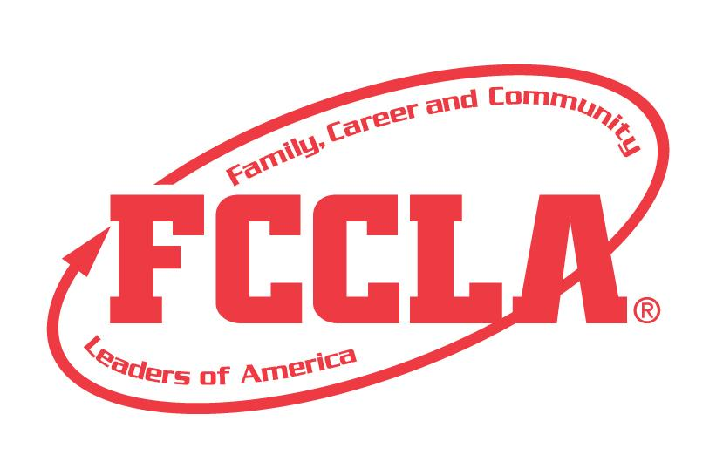

Career Exploration

STATE PROJECT

FCCLA members must be affiliated by February 1st
Career Exploration

Overview: Career exploration is a project recognizing individual students who use the planning process to research careers, assess skills, and form a career plan. Students must create a portfolio and planning process summary page demonstrating the knowledge gained about the career they researched.

Entry: Individual event

PORTFOLIO GUIDELINES:
- For this project a PDF file can be submitted electronically OR a Three Ring Binder can be used.
  - Three Ring Binder: this can be in the official FCCLA red or white three ring binder (can be purchased through the E-Store)
  - PDF File: For submission, please submit portfolio as one pdf file. Name the file with the student first and last name, chapter name, and name of the state project.
- A title or title page must be on the front of the portfolio. The title of the project, Career Exploration must be included. A subtitle is optional.
- There must be a project identification page (8 ½” X 11”) page in the portfolio identifying:
  - Participant name
  - Participant grade
  - Name of chapter
  - Name of school, school address, city and state
  - District number
- Includes planning process summary page up to 2 pages
- Up to 20 pages TOTAL

PROJECT DETAILS:
- Each step of the Planning Process is fully explained, neatly typed and placed in the portfolio.
- The portfolio must include explanations and evidence of the following:
  - Self-Assessment- Complete the interest assessment at Indiana Career Explorer or use a comparable assessment from a similar platform (Naviance, etc). Print and include the results in the portfolio. Additionally, complete one additional career or interest survey of your choosing, print and include in the portfolio. (2 total assessments)
  - FCCLA Career Exploration Sheet- reference Self-Assessment results to answer the Career Exploration questions (attached) on up to two 8 1⁄2” x 11” pages
  - Use of Family and Consumer Sciences Coursework/Standards- Describe ways that Family and Consumer Sciences courses and/or standards will help prepare you for the selected career on one 8 1⁄2” x 11” page.
  - Career Planning- state career goals in a paragraph(s) summary on one 8 1/2” x 11” page.
  - Education Plan- utilizing the education plan sheet (attached), create an education plan and include in your portfolio.
  - Document experiences or exploration in selected career field. Examples of documentation may include, but are not limited to, written summaries of interviews from business, industry, agency, or organization personnel; written narrative of job shadowing or cooperative work experiences; community service or project-based learning, and photographs.

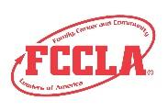
FCCLA Planning Process
Summary Page Template
(This template may be modified, but all headings must be used in the correct order. The FCCLA logo and
Planning Process graphics are encouraged but not required.)

IDENTIFY CONCERNS

SET A GOAL

FORM A PLAN (WHO, WHAT, WHEN, WHERE, HOW, COST, RESOURCES, AND EVALUATION)

ACT

FOLLOW UP

CAREER EXPLORATION

Self Scoring is Optional
EVALUATION |  |  |  | Self-Score | Score
PORTFOLIO  0-10 pts | Does not meet size specification and missing title and project ID page  0-3 | Does not meet size specification or title or project ID page missing, incomplete, or not organized  4-7 | Meets size specification, title and project ID page included  Neat and well organized  8-10
FCCLA PLANNING PROCESS  0 – 15 pts | Not included or not well developed  0-4 | Included but not complete  5-9 | Planning Process is fully explained, neatly typed or written, and included  10-15
GRAMMAR  0 – 10 pts | Extensive grammatical and spelling errors  0-3 | Few grammatical and spelling errors  4-7 | No grammatical or spelling errors  8-10
SELF-  ASSESSMENT  0 – 10 pts | Missing  0-3 | Incomplete or not all surveys taken  4-7 | All surveys completed and included  8-10
CAREER EXPLORATION SHEET  0 – 15 pts | Missing or not complete  0-4 | Somewhat complete, not detailed  5-9 | Good research information. Very thorough and detailed  10-15
USE OF FCS COURSEWORK /STANDARDS  0 – 10 pts | Missing or not complete  0-3 | A few examples of FACS coursework/standards but not detailed  4-7 | Very detailed examples of FACS coursework and standards  8-10
CAREER PLANNING  0 – 10 pts | Missing or not complete  0-3 | Summary basic, not detailed  4-7 | Very complete and detailed plans for career goals  8-10
EDUCATION PLANNING  0 – 15 pts | Missing or not complete  0-3 | Basic information, not detailed  4-7 | Complete and detailed education plan included  8-10
EXPERIENCE/  EXPLORATION  0 – 5 pts | Missing  0-3 | Experience included but not relevant  4-7 | Relevant experiences included  8-10
Total 100 pts possible

Comments:

Name__________________________________________School___________________________________

0-69 | 70-79 | 80-89 | 90-100
Participation | Bronze | Silver | Gold
CAREER INVESTIGATION SHEET
(2 pages maximum): PRINT OR TYPE

- From the recommended industries on the Indiana Career Explorer assessment, what industry interests you most? Why?

2. Please list a specific job title and description for a job in your chosen industry or pathway.

3. What skills are needed for this career?

4. What is the current and future job outlook for this career?

5. Mentorship is a big component in education/training job sustainability. Who could be a mentor to you and what other measures could you take to ensure a long, enjoyable, and successful career?

6. What are the entry-level positions and opportunities for professional advancements in this career field?

7. Please list your sources for your career research.

Education Plan for CAREER INVESTIGATION
(2 pages maximum): PRINT OR TYPE

Career Goal:
Summary of Your Plan to Reach Career Goal:
High School Plan (Diploma Type, Courses of Interest, and Pathway Courses if applicable):
Extra-Curriculars:
Skilled Training, Post-secondary, and/or College: (Two Possible College/Post-secondary options or Training Options, degree option if applicable):

